Wa Outreach in Thailand – Annual Report 2009

Frontier Mission Project of the Presbyterian Church (USA)

April 8, 2010

Wa Christian Fellowship (WCF)
P.O. Box 21
Chiang Mai 50000
THAILAND

Mr. David Eubank, Director
P.O. Box 14, Mae Jo
Chiang Mai 50290
THAILAND

Dear Friends of the WA,

We thank you for continuing to care about and help the Wa people of Northeastern Burma and their cousins, the Lawa of Thailand. 73 new Wa believers were baptized in 2009 and 2010.

Background of Wa People
Most of the Wa people live in the Wa and Shan States on the borders of Thailand, China and Laos. Their home in the Wa Hills of Burma is not easily accessible, even for us who live relatively close in Northern Thailand. The drug trade in this region is prolific and fierce and contributes to the atmosphere of hostility and suspicion that hang over the Wa people.

The combination of narcotics, collusion with the dictators, conscripting children to fight in the army, and attacking other ethnic groups make the United Wa State Army (UWSA) an easy scapegoat.

But the Wa people themselves have very little choice and are pawns in a deadly game. Animism continues to grip the people, and the threat of attack by the Burma Army means that most Wa live in uncertainty and fear.

In spite of the hostile circumstances, God’s grace has reached the Wa. In 1908 the first Wa became Christian. Now, over 50,000 Wa in Burma are believers and there are reportedly over 100,000 Wa Christians in China. God is working through them and others to overcome many challenges inside and outside of the Wa church. His light continues to shine among the Wa.

In spite of the turmoil surrounding it, the church keeps growing and the mission to the Wa continues. Thank you for your part in that growth.

The Eubank Family
David and Karen and their family spend most of their time on foot in Burma, walking to relief missions in the war zones of the Karen, Karenni and Shan States, serving internally displaced people. They have been able to serve and minister to Wa people in the Wa Southern Relocation Site in Shan States near the Thai border, but because of the Wa partnership with the Burma dictators, they have not been able to go to the Wa areas of Burma since 2000.

However, they actively support the Wa pastors who evangelize their people with both finances and prayer. David’s family then go where they can into the other ethnic areas where the Burma Army is conducting attacks against the Karen, Karenni, and Shan people. In these areas it is a Burma Army policy to shoot on sight. But by moving with the ethnics, they have been able to avoid the Burma Army.

When the Eubanks are in Thailand they meet with the Wa Christian Fellowship (WCF) to pray, assess the work, make plans and encourage each other.

The Lawa People
- Lawa is the name used for the ethnic Wa in Thailand.
- Wa is the name of the language and the people-group elsewhere in the region (Burma and China).
- There are an estimated one million Wa people in the northern Wa area and China.
- Approximately 200,000 Wa live in the southern area north of the Thai border.
- In Thailand there are fewer than 100,000 ethnic Lawa immigrants, including their children and grandchildren as well as descendants of the original inhabitants of the northern Thailand area surrounding Chiang Mai.

The Wa Christian Fellowship (WCF)
- is part of the 18th District of the Church of Christ of Thailand (CCT).
- Pastor John Saniex, administrator of the Lawa Student Hostel is a founding member of the WCF and serves as secretary. He also pastors the Wa church of Chiang Mai, which currently meets at the Hostel.

Current Projects

Lawa Student Hostel

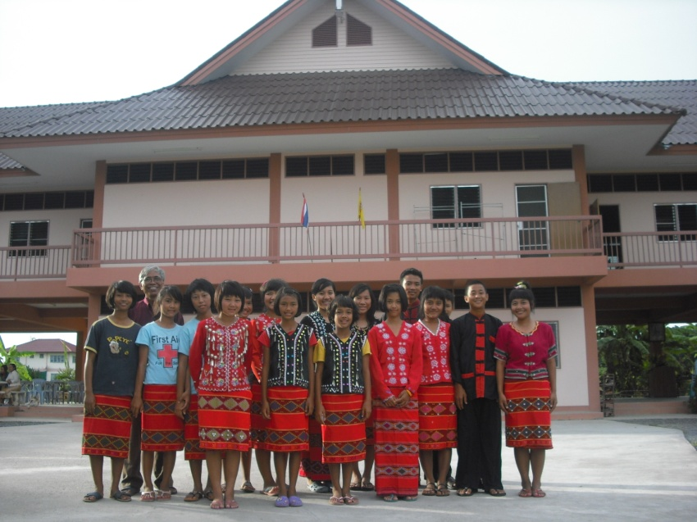
We thank the Community Presbyterian Church of Vacaville, California, for the salary of Wa pastor/evangelist John Saniex, who is under the oversight Allan Eubank.

We praise God that the new 2-story permanent dormitory building was completed. Hostel ties with the local community have been strengthened.

The hostel is thriving with 44 young people and four of these students are now enrolled in university in Chiang Mai. Most of the students come to Chiang Mai from villages and towns in northern Thailand for a good public education and Christian nurture in a bi-lingual (Wa-Thai) language environ-ment.

When volunteers are available, they teach English and computers on the computers the Rotary donated. Daily worship services at the hostel are conducted by the house parents, Rev. John Saniex and his wife, Sophia.

This has been a great year for the Lawa hostel with both growth and momentum.

The hostel hosted its first team visit from the States in November of last year. The team helped us build a library with nine study desks and lamps, 3 moveable bookshelves, and provided air-conditioning and brand new proper lighting for study purposes. In addition, a small basketball court was built by the team for the students to enjoy.

The hostel has grown to 44 students this year. Eleven children successfully graduated from the local school and we were proud to send them into their future with an education and strengthened faith and training.

This year we have welcomed 11 new students who will receive the same opportunity for education and leadership training.

In addition, two of our students were accepted into local universities. We thank God that this year we have a total of six students attending university in Chiang Mai. All of these students grew up in the hostel. One of the young men, Uraiwan, will be are first Wa student to attend seminary. We praise God for His faithfulness in these young lives.

We’ve also been blessed with the addition of a strong Christian Wa women and her husband who came to live and work at the hostel, assisting Pastor John in his wife in parenting the children.

Chiang Mai International School students have come to the hostel to help on maintenance projects and to teach computer skills to the children for their community service requirement. They also teamed with the Lawa students to paint the old office.

The WCF invited youth leaders to form a Lawa Youth Council in 2006. The Youth hope to develop leadership skills, to mentor the younger members and to lead the Lawa (Wa) community into challenging opportunities working with Wa Christians in other countries of the region. Miss Uraiwan Kornlao, who is president of the Lawa Hostel students and just graduated from high school, went with other Lawa Church members to Mong Mao, Burma, for the Centenary Christian Jubilee in April 2008. Because of her trip she was able to bring back a broader vision of the Wa Church to share with the other students.

In spite of the fact that the Hostel has only had funding to feed 22 students, we’ve stretched the budget to feed and support 38 students.

Now, with extra support from Allen Eubank and a generous donation from the Rotary Club in California, we have the proper funding for food for all 44 students. This was a crucial
prayer request last year and we are grateful for the provision and ability to care for more children.

Crucial Need at the Hostel
This year, the Government has changed the rate of educational taxes that must be annually paid by the hostel. In addition to higher taxes, the school system has cut back their support for school supplies and uniforms and the financial assistance given in the past for the Wa students. An extra annual payment of forty five thousand baht (US 1, 395.00) must be paid by the hostel for all the children. This new cost is not covered in the annual support of the hostel.

Evangelists
We support eight evangelists working full time in the northern Wa District, six directly and two indirectly. Five of these are teacher-evangelists who are based at the Ying Phang Hostel and School. Another teacher-evangelist is serving at Cao Tie village, the old hostel site.
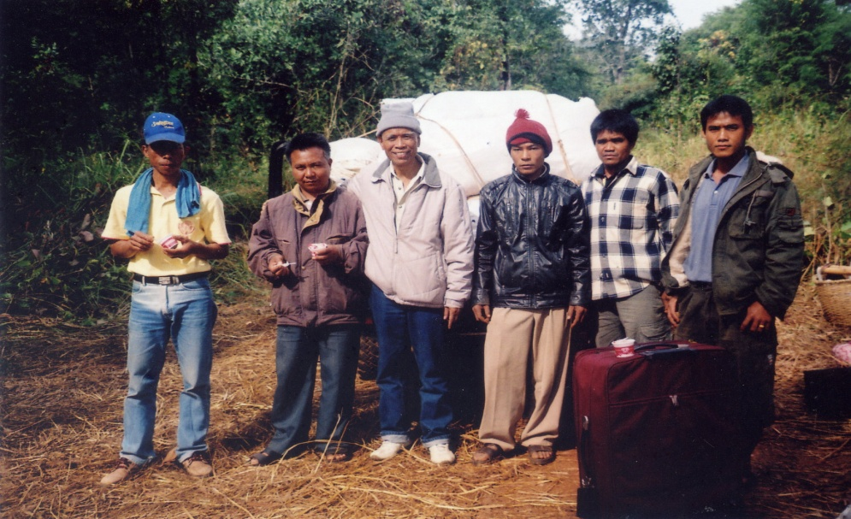
Another Evangelist/Pastor travels to both sides of the border and also on Wa evangelistic trips to the northern Wa District. We also have a Wa Pastor/Evangelist who travels the Thai side of the border, sharing the gospel with the Lawa people.

Evangelism/Outreaches The Wa Evangelists are engaged in teaching and preaching at various villages in the northern Wa State area and in the Southern region as well. These men travel across the borders to preach and teach and provide medical and relief supplies to poor Wa villagers. There are also on-going outreaches by Lawa Evangelists to Lawa villages in Thailand border areas.

The evangelistic team also traveled to:
- Nam Yung District
  - Nawng Vien
  - Nambaw Loe
  - Nam Phai
- Nakawng Nu District
  - Man Siang
  - Meung Mau
  - Wa Leun
- How Aw District
  - Hong Leek

Our first Wa student from the hostel to graduate from a local university visited seven Wa districts with Pastor John of the Lawa Hostel and Pastor Banjong.
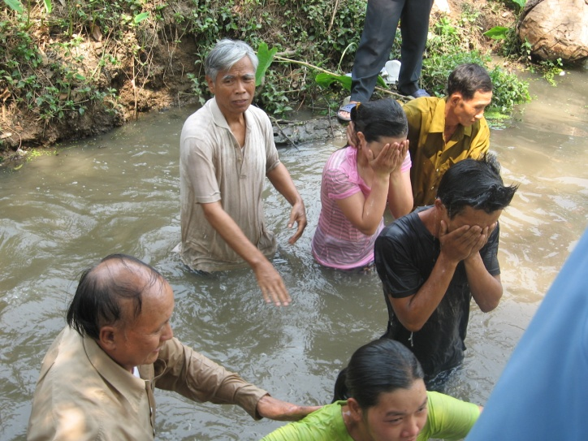
73 new Wa believers were baptized in 2009 and 2010.Their first visit was on the 23rd of December 2009, the second trip on February 1-9 A total of 73 people were baptized. The majority of these converts were sprit worshipers.

This was a historical event for the Lawa Hostel as it demonstrated the vision of the hostel: educating and training the Wa children to become leaders among their own people.

Ying Phaung Hostel and School –
Sixty impoverished Wa children live and study at Ying Phang Christian Hostel and School in the Northern Wa District near the border of China. Some have lost one or both parents. Others are from poverty-stricken families. An additional 32 children attend school during the day totaling 63 children cared for by this ministry. The hostel has been in operation for over eight years, thanks to the Kachin and Wa missionaries who are faithfully serving to witness for Christ in a poverty-stricken area. Through special gifts, we have been able to provide support for three to six months out of the year on average (in addition to the teacher-evangelist salaries) and have depended on the Wa church, the UN World Food Program and the grace of God for the balance.

Medical care
We are also involved with providing medical care for the Wa people. The Lawa church has helped individuals who cannot afford their hospital bills. Lawa pastors and church members travelled across the border to a poor Wa village, Na Kawng Mu, in the Southern region, and supplied them warm clothing, blankets and medicines to treat the most common illnesses in that area.

Christian Literature
The work to translate, edit, publish, and distribute a complete Wa Bible, Old and New Testament, is ongoing. The 2006 Bible has now been revised. Copies of the new revision are now being given to Wa people in Burma and Thailand. Evangelism material and Sunday School materials in the Wa language are being distributed in the Southern Wa region by other mission groups as well.

Rotary Clubs
Our relationship with the rotary clubs is ongoing and has been pivotal to the success of the student hostel. The rotary clubs were instrumental in providing special facilities for the new hostel building, such as the outdoor sanitation system, the four adjacent outdoor bathrooms, and other needed equipment. Adele Anderson coordinated the matching grant application with Rotary Clubs in Tempe, Arizona; Walla Walla, Washington; and Chiang Mai, Thailand along with the Rotary Foundation.

Update on Present Challenges

Ying Phang Hostel

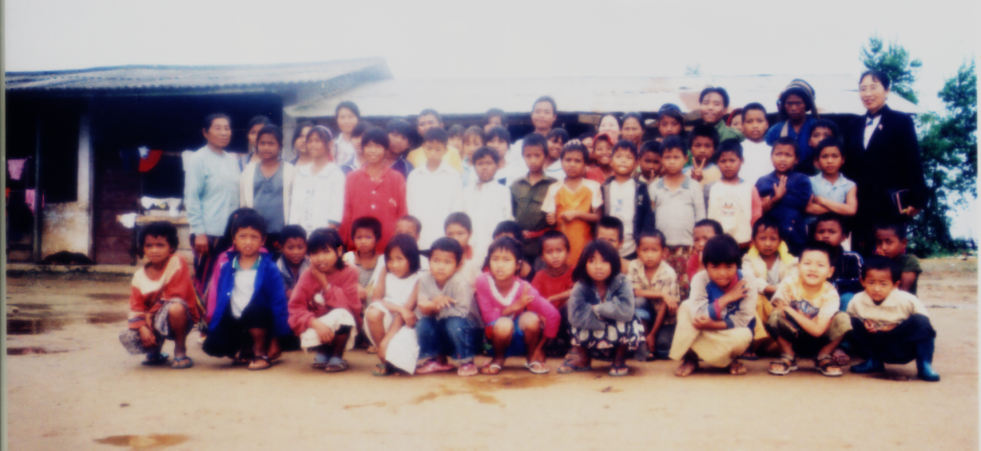
The food supply for the children and staff at Ying Phang Hostel is still not secure. In January, 2008, we met with Roi Ji, the hostel director who told us of the Wa District government initiative to construct another school and Hostel building on the ten acre site.

In the event that the UN World Food Program should end the school rice-feeding project, the hostel needs a plan for food-sufficiency in place for the future survival of the Hostel.
In view of this, the Hostel currently grows a vegetable garden to help feed themselves their five pigs and some chickens.

However, for this project to be successful, they need:
  - Five more pigs
  - Fencing for the crops to keep cows and buffalos out.

They lost half their crop last year and future cash crops (3 years to maturity) are being damaged as well.

Evangelism in Northern Wa Special District
The six full-time evangelist/teachers based at Ying Phang continue their work sharing the gospel, strengthening believers and teaching. A new Christian worker, Nyi Rung, has been called to serve as pastor-evangelist and is supported by the Lawa Church in Chiang Mai.

The Ying Phang evangelists have made the spiritual nurture of the hostel and school
children their focus. They believe that these children are key in leading their families to Christ. Their vision is that these children will be bridges for their people to know Christ.

Please pray with us for Wa Christian workers in northern and southern Wa areas of Burma and in Thailand, as well. Wa Christian workers many times must continue forward on a wing and a prayer from fellow Christians around the world because of lack of funding, and the strong local non-Christian opposition to their work as well as internal divisions in the Wa church.

Evangelism in Southern Wa Areas
Some time ago, the Wa authorities forcibly relocated large numbers of Wa from their villages in the north down to the southern border areas. Consequently, there are a number of very poor villages just across the Chiang Mai Province border with Burma near Chiang Dao.

There are 22 families in the Na Kawng Mu Church and some 50 families in the whole village of Man Siang (named after their home village up north). They are eager to share the gospel with their fellow villagers, but their helper, the 80 year old Lahu missionary pastor, is about to retire. He has been teaching a dedicated layman who loves the Lord and is ready to start Bible teaching.

Need for 100 dollars a month for this evangelism project.
Pastor Banjong, on the Thai side of the border, wants to take on some evangelism duties and to structure a training program for the lay teacher if he can cross the border on a regular basis
Thank you very much for your continuing support and prayers. The Wa Christian Fellowship is very grateful to you and the Presbyterian Churches of the PC (USA) for your partnership in reaching the Wa for Christ. In spite of living on opposite sides of the world, we thank God for bringing us together for this cause.

The Wa face many obstacles, but God’s light is shining on them and the darkness will not put it out.

We sincerely welcome a representative of the PC (USA) to visit any of the projects at any time that would be convenient to you.

Respectfully submitted,

Joshua Dunham
Wa coordinator
On behalf of the Eubank family and the Wa Christians

Wa Student Hostel Budget

Income:

Thai Christian Foundation – $4,464.75
World Aid $600
Christians Concerned for Burma $8,472

Total Income - $13,536.75
EXPENDITURES
TB $U.S
Salary for Hostel Parents |  |  |  |  |  |  |  |  |  | 60,000 | TB | 1,857.87
Support for Evangelist, Ye Thai |  |  |  |  |  |  |  |  |  | 12,000 | TB | 371.71
Rice |  |  |  |  |  |  |  |  |  | 49,870 | TB | 1,544.89
Food |  |  |  |  |  |  |  |  |  | 76,000 | TB | 2,354.39
Cooking Gas |  |  |  |  |  |  |  |  |  | 7,120 | TB | 220.5
Motorcycle and Truck fuel/ maint/ |  |  |  |  |  |  |  |  |  | 77,081 | TB | 2,387.18
Electricity |  |  |  |  |  |  |  |  |  | 27,742 | TB | 859.15
Telephone Bill |  |  |  |  |  |  |  |  |  | 17,610 | TB | 545.37
Tuition, books, and school uniforms |  |  |  |  |  |  |  |  |  | 94.819 | TB | 2,936.48
Food for Pastor John's Family |  |  |  |  |  |  |  |  |  | 14,400.00 | TB | 445.91
Food for House Parents |  |  |  |  |  |  |  |  |  | 10,800 | TB | 334.46
Other Expenditures |  |  |  |  |  |  |  |  |  | 13,712 | TB | 424.65
460,244 14,253

